**Sardar Patel Institute of Technology**

Bharatiya Vidya Bhavan’s Bhavan’s Campus, Munshi Nagar, Andheri (West), Mumbai-400058-India

(Autonomous College Affiliated to University of Mumbai)

**Applied Science and Humanities Department**

**Academic Year:** 2021-22

**Class:** F.Y.B.Tech **Sem.:** I **Course:** ET101 Basic Electrical Engineering Lab

UID: 2021300098, 2021300099, 2021300100, 2021300101



SINGLE PHASE INDUCTION MOTOR

**Working principle of a single phase Induction motor**

Consider two winding 'A' and 'B' so displaced that they produce magnetic field 90° apart in space. The resultant of these two fields is a rotating magnetic field of constant magnitudeϕm. Non-Uniform magnetic field produces a non-uniform torque which makes the operation of the motor noisy, affect starting torque.

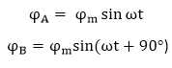

A single phase induction motor consists of a single phase winding on the stator and a cage winding on the rotor. When a 1 phase supply is connected to the stator winding, a pulsating magnetic field is produced. In the pulsating field, the rotor does not rotate due to inertia. Therefore a single phase induction motor is not self-starting and requires some particular starting means. Two theories have been suggested to find the performance of a single phase induction motor.

1. ***Double Revolving field theory******2) Cross- field theory***

**Characteristics of a split phase Induction motor** :1) The starting torque of split phase induction motor is 1.5 to 2 times of the rated fullload torque and the starting current is 6 to 8 times of the full load current.

* The cost of split phase induction motors is very low, due to which these are very popular in the market.

## Characteristics of Capacitor-Start and Capacitor-Run Motor

* In case of capacitor-start and capacitor-run motor, the starting winding and the capacitor can be designed for perfect two-phase operation at any load. Thus, this motor produces a constant torque.
* Because of constant torque, the capacitor-start and capacitor-run motor is vibration free.

## Characteristics of Shaded-Pole Motor

* The principle characteristics of shaded-pole motor is the extremely simple construction and absence of centrifugal switch.
* These motors are available in power ratings upto about 30W.

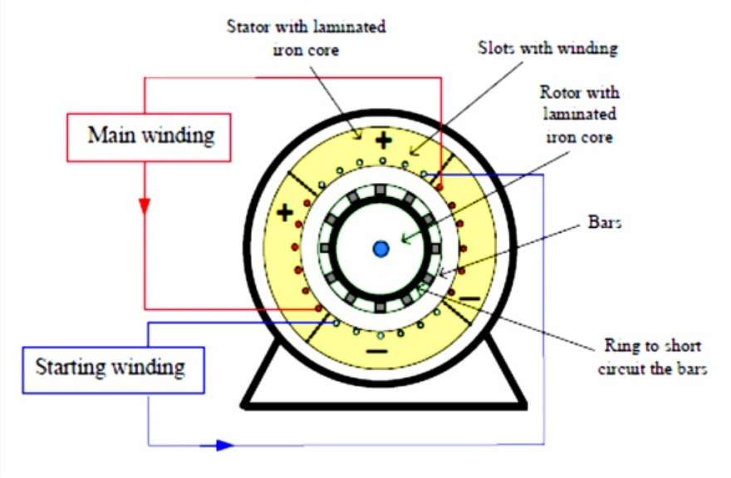

THREE PHASE INDUCTION MOTOR

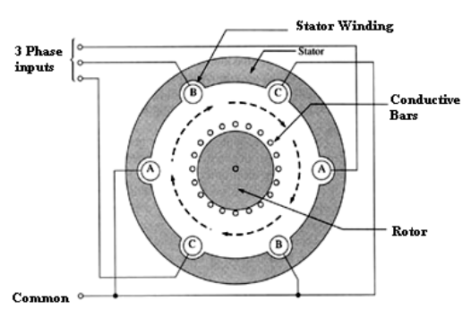

Working principle of Three phase Induction Motor

(1) When the 3 phase stator winding is energised from a 3 phase supply, a rotating magnetic field is produced which rotates around the stator at synchronous speed.

(2) The rotating magnetic field cuts the rotor conductors, which as yet, are stationary. Due to this flux cutting, emfs are induced in the rotor conductors. As rotor circuit is short circuited, therefore,  currents start flowing in it.

(3) Now, as per Lenz’s ,  "the direction of induced current will be such that it opposes the very cause that produced it "

(4) Here, the cause of emf induction is the relative motion between the rotating field and the stationary rotor conductors. Hence, to reduce this relative motion, the rotor starts rotating in the same direction as that of the stator field and tries to catch it but, can never catch it due to friction and windage and therefore emf induction continues and motor keeps rotating.

When rotor winding is short-circuited with no resistance in series, it is called a ***squirrel cage induction motor*** and when rotor winding  is shorted through a resistance in series, it is called ***slip ring induction motor***.

Thus, ***principle of 3 phase induction motor*** also explains why rotor rotates in same direction as the rotating field  and  why *induction motor is self starting*.

Characteristics of a Squirrel Cage Induction motor

1. The induction motor has very high starting current.
2. SCIM has very low starting torque.
3. Starters like direct on line starter and star Delta stator can be used to reduce the starting current…
4. At starting time the rotor speed is zero so it is called blocked rotor condition.
5. The slip at starting of IM is always maximum which is one
6. In case of SCIM we can not add external resistance to develop the starting torque..